DEVOPS

PROJECT – 2:
Building complete AWS Infrastructure using Terraform, including VPC networking, EC2 compute, ALB load balancing, ASG auto-scaling, CloudWatch monitoring, and SNS alerting.

TOOLS USED IN THE PROJECT:
- Terraform: Infrastructure Creation.
- GIT: Version Control.

PROJECT OVERVIEW:
This project provisions a complete highly available, auto-scalable web application infrastructure on AWS using Infrastructure as Code (IaC) with Terraform.
The architecture includes:
- Custom VPC (10.0.0.0/16 CIDR)
- Public & Private Subnets across multiple AZs
- Internet Gateway & NAT Gateway
- Elastic ip
- Application Load Balancer (ALB)
- Launch Template (Ubuntu + Apache)
- Auto Scaling Group (ASG)
- CloudWatch Metric Alarm (CPU > 70%)
- SNS Email Alert Notification

STEP 1: Create Instance
- Create EC2 Instance: (Instance -1)
- Name: Terraform
- No. of Instance: 01
- AMI: Ubuntu Server 20.04 LTS (HVM), SSD Volume Type
- Instance type: t3.micro
- Key Pair: ubuntu
- Security Group: All-tcp

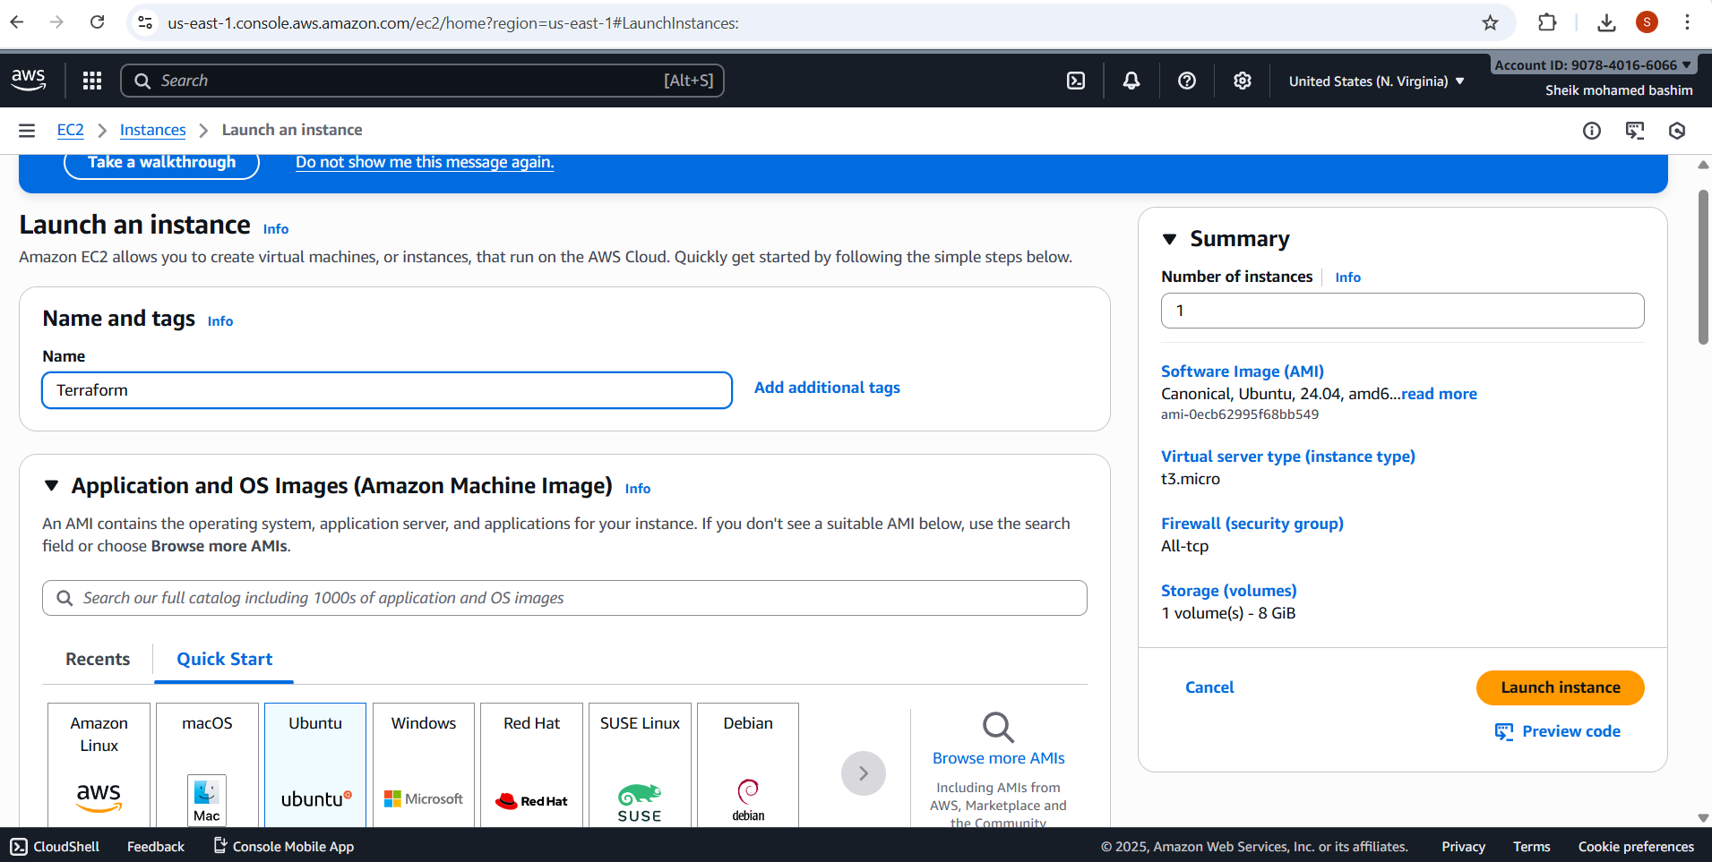

- Launch Instance

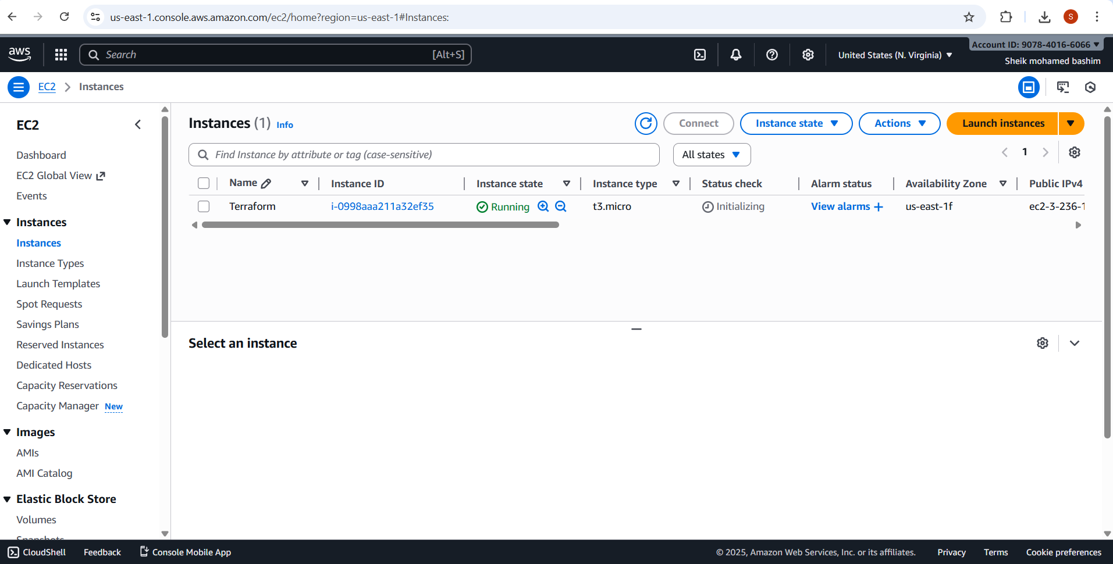

STEP 2: Putty Connection & Login
Command:
- ubuntu
- sudo -i
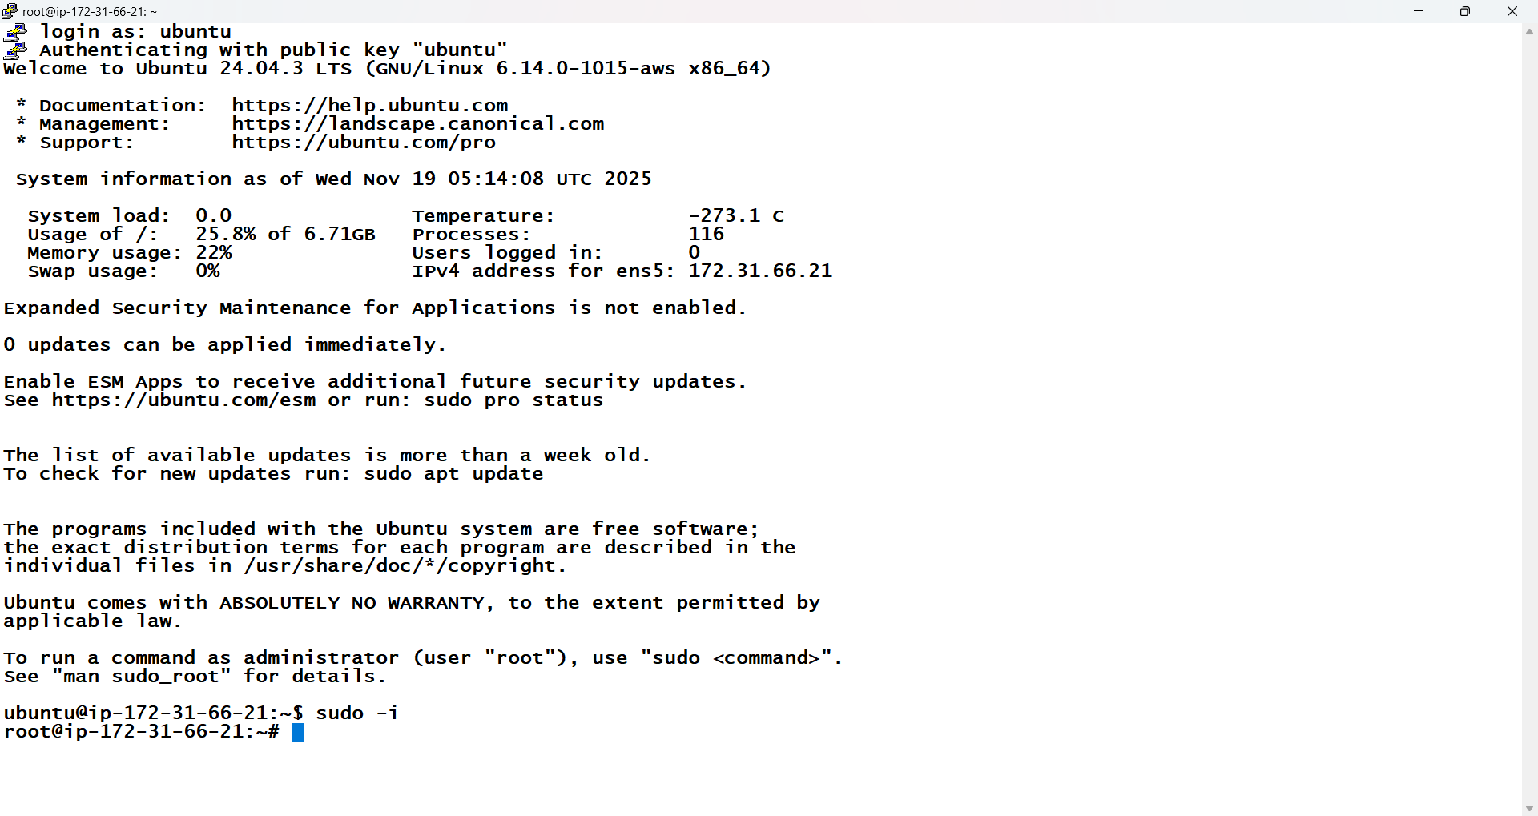
STEP 3: Update and Download Terraform v1.0.0 (Linux 64-bit)
- sudo apt update
- wget https://releases.hashicorp.com/terraform/1.0.0/terraform_1.0.0_linux_amd64.zip
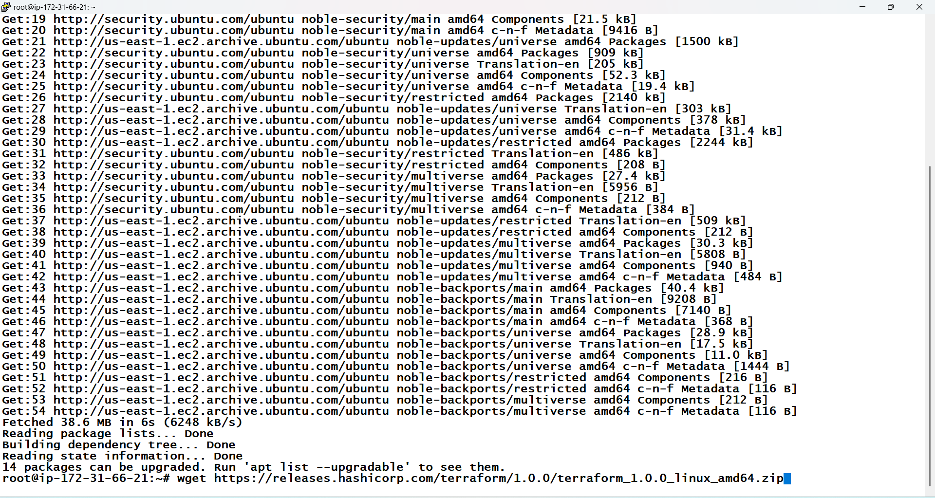

STEP 4: Install unzip and Unzip the file
- apt install unzip
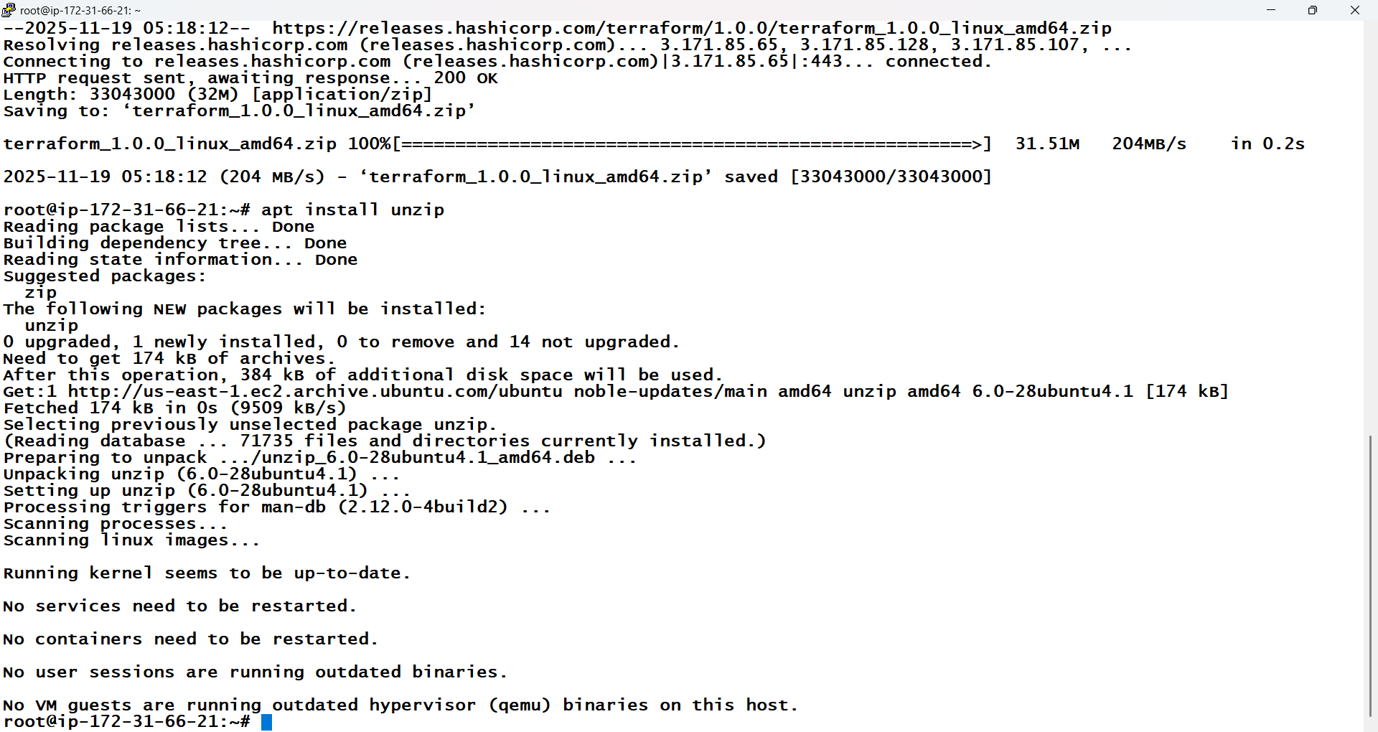

- unzip terraform_1.0.0_linux_amd64.zip

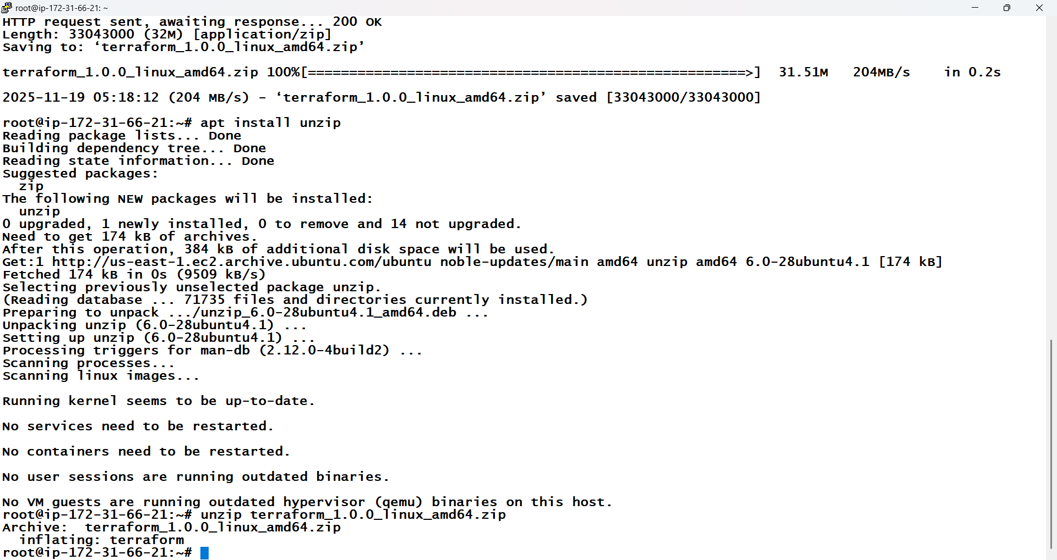

STEP 5: Remove the terraform zip file
- rm -f terraform_1.0.0_linux_amd64.zip

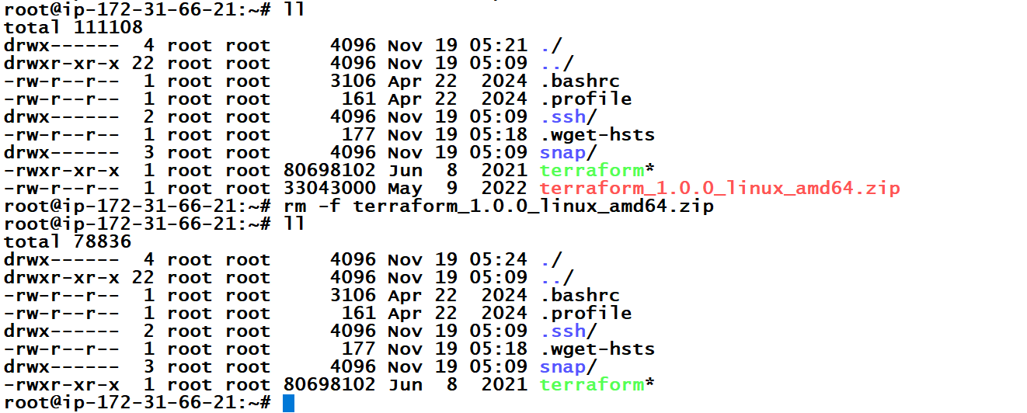

STEP 6: Move the terraform binary to /usr/local/bin
- sudo mv terraform /usr/local/bin/

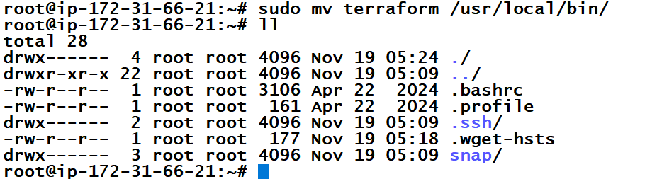

STEP 7: Verify the installation
- terraform -v

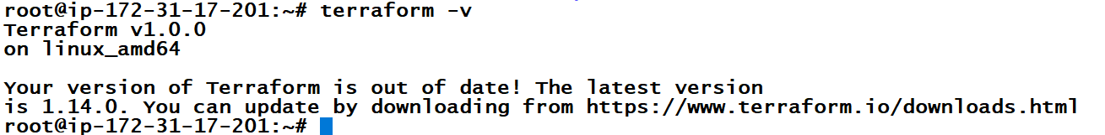

STEP 8:
Open the Terraform configuration file using vi main.tf, then run terraform init to initialize the project, use terraform plan to review the execution plan, and finally apply the infrastructure using terraform apply.
- vi main.tf
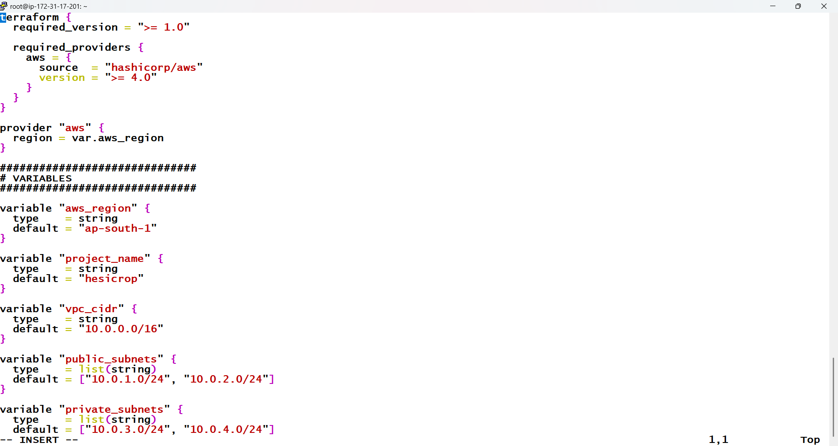

- terraform init

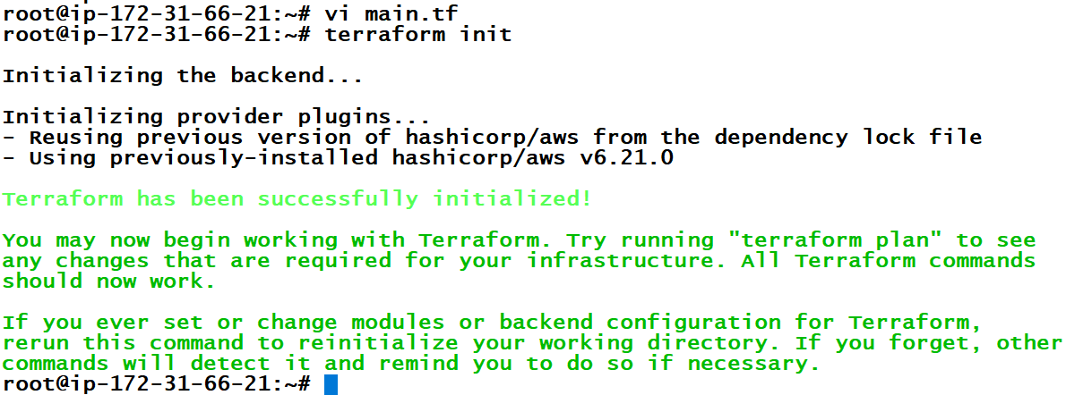

- terraform plan

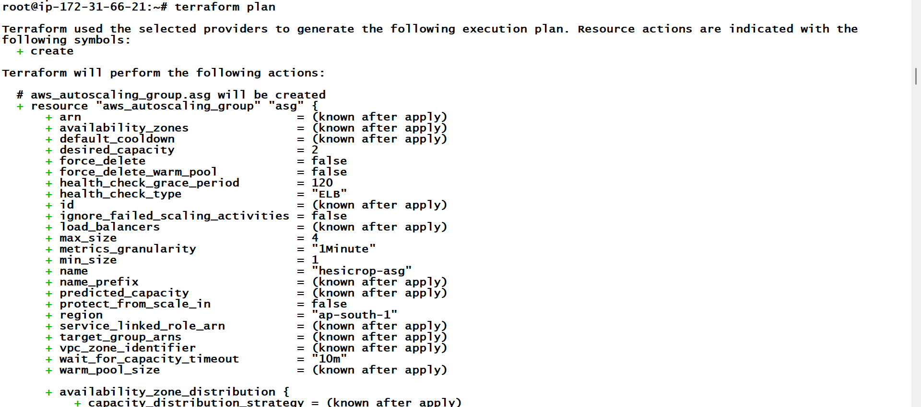

- terraform apply
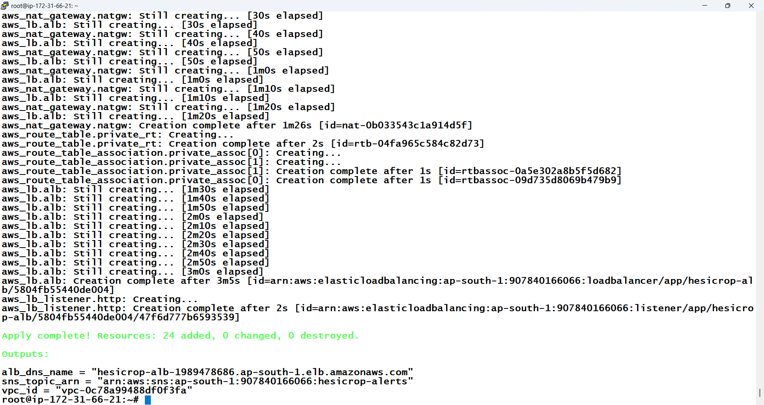

STEP 9:
- Automatically VPC, Subnet, Route table, Internet Gateway, NAT Gateway, Elastic ip, Launch Template, EC2 Instance, Autoscaling Group, Target Group, Elastic Load Balancer, Cloud Watch and SNS will create.

STEP 10: New VPC is automatically created.
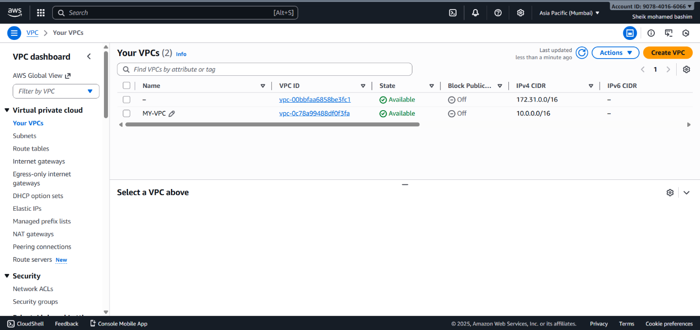

STEP 11: New Public and Private Subnet is created automatically.
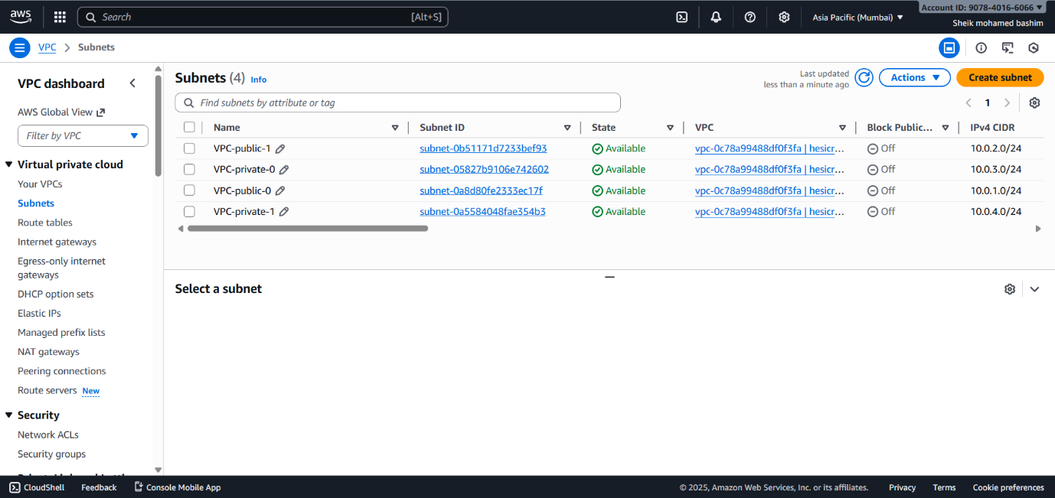

STEP 12: New Public and Private Route table is created automatically.
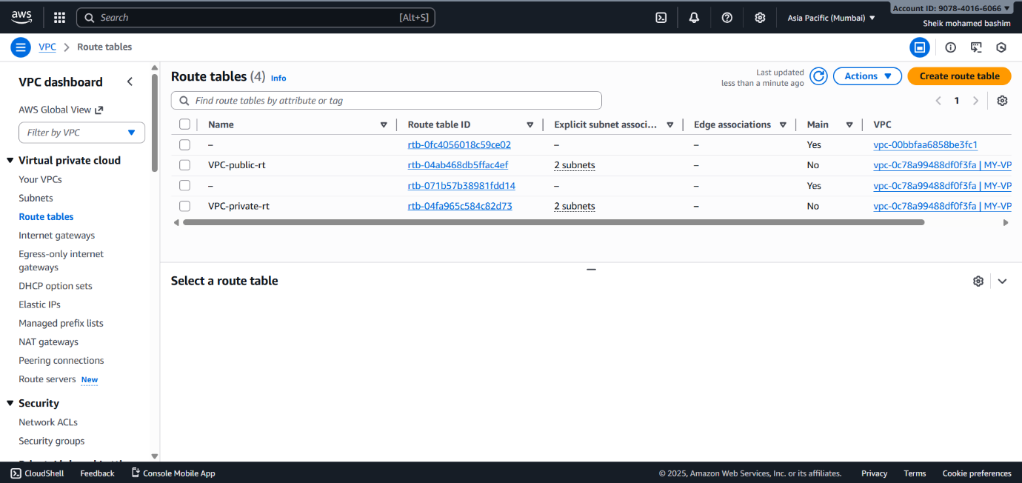

STEP 13: New Internet Gateway is created automatically.
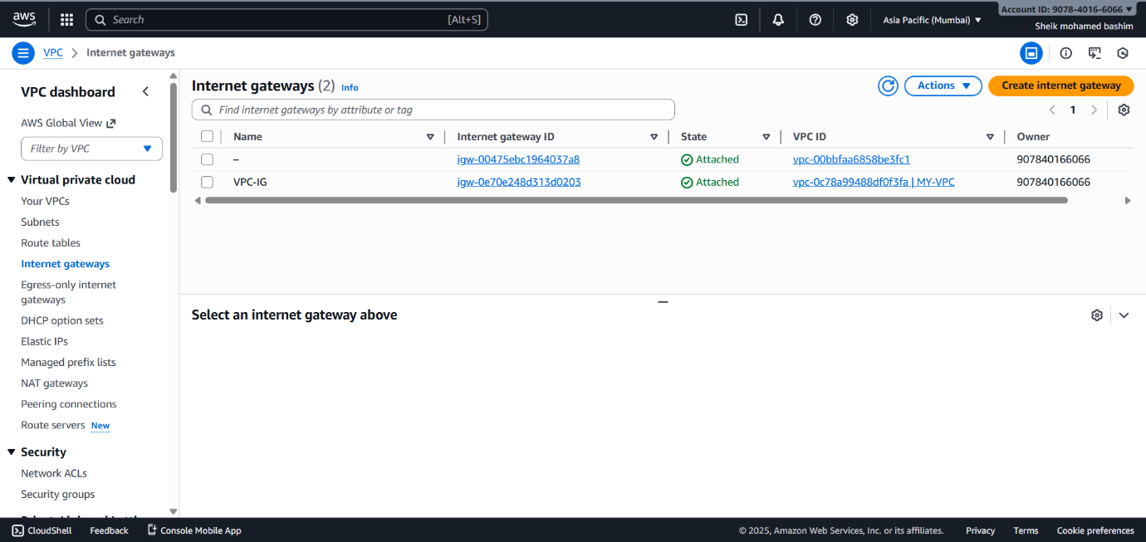

STEP 14: New NAT Gateway is created automatically.
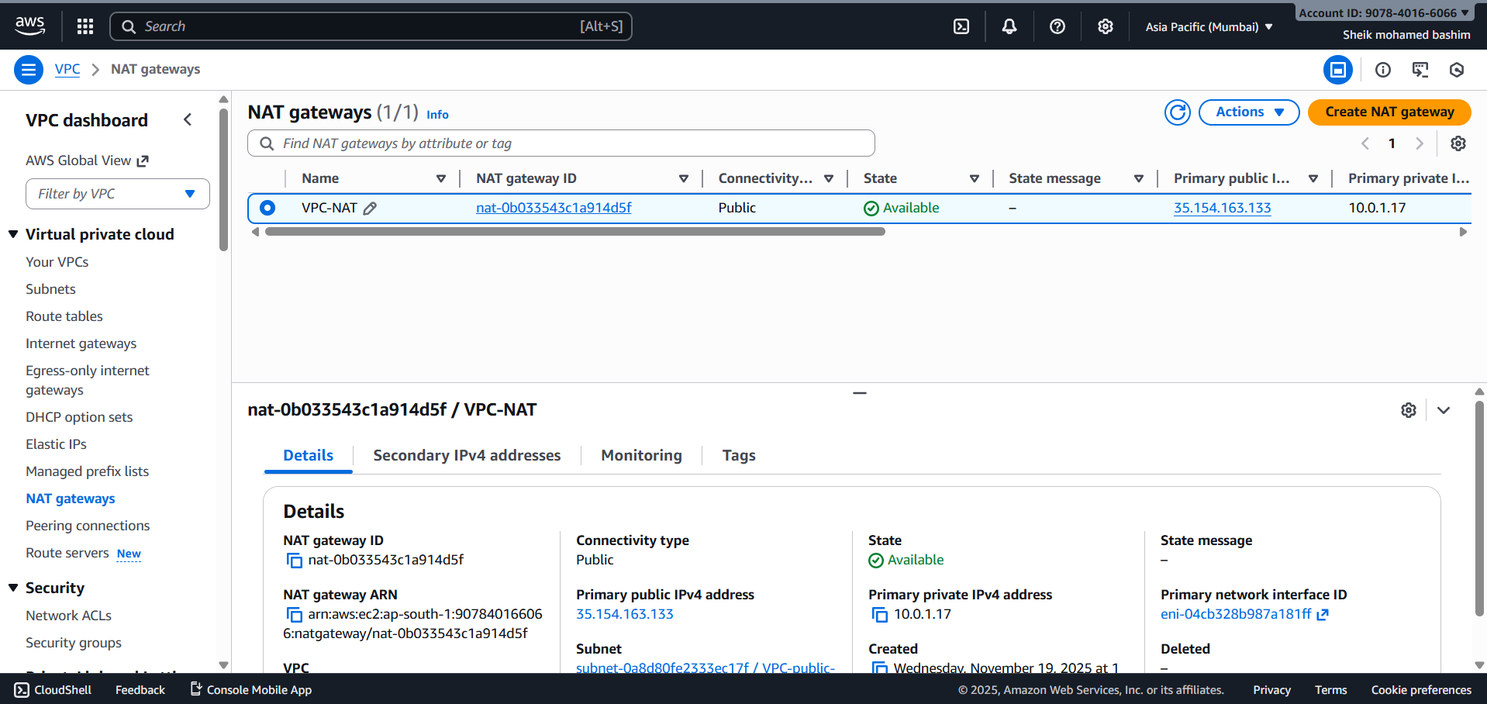

STEP 15: New Elastic IP is created automatically.
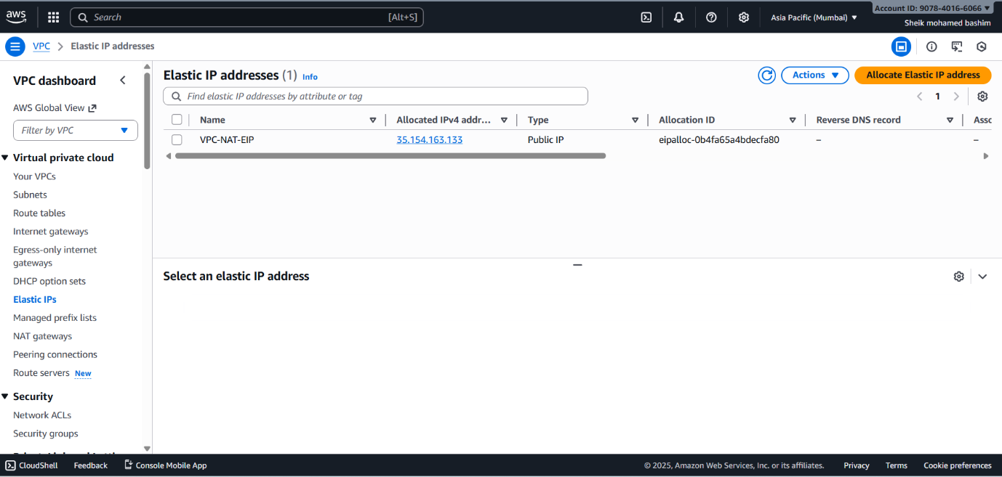

STEP 16: New Launch Template is created automatically.
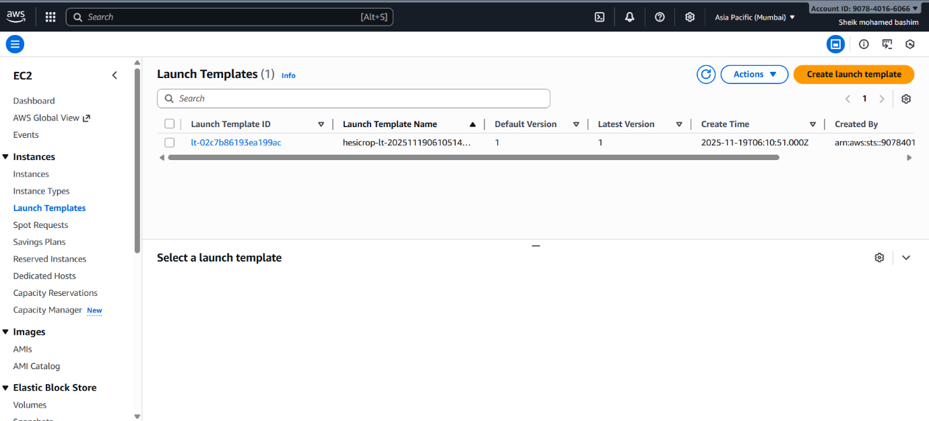

STEP 17: New 2 EC2 Instance is created automatically.
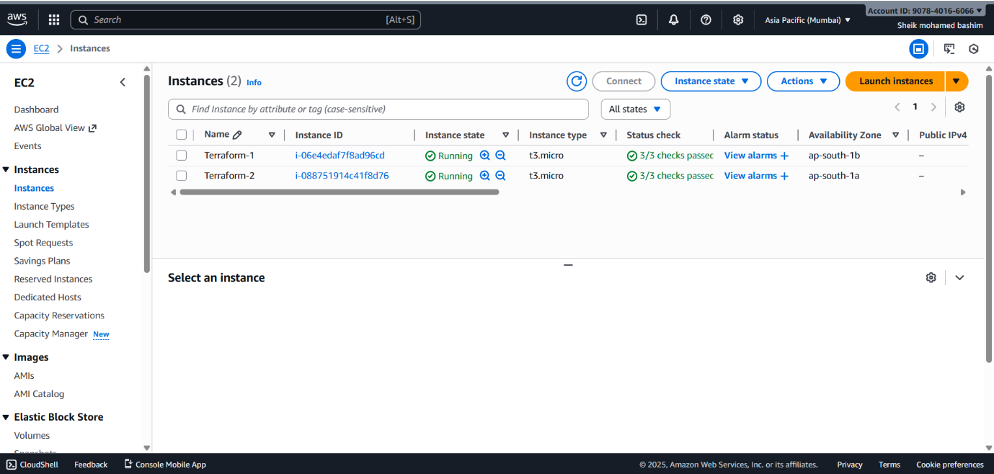

STEP 18: New Auto-Scaling Group is created automatically.
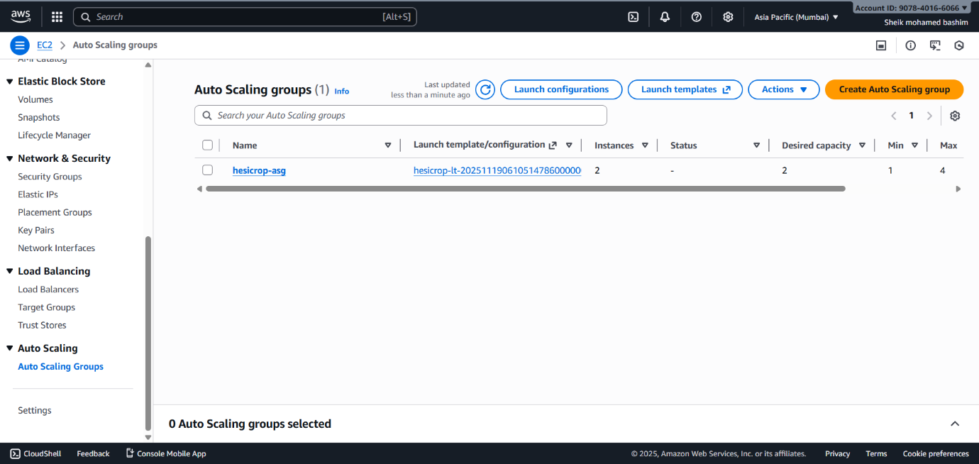

STEP 19: New Target Group is created automatically.
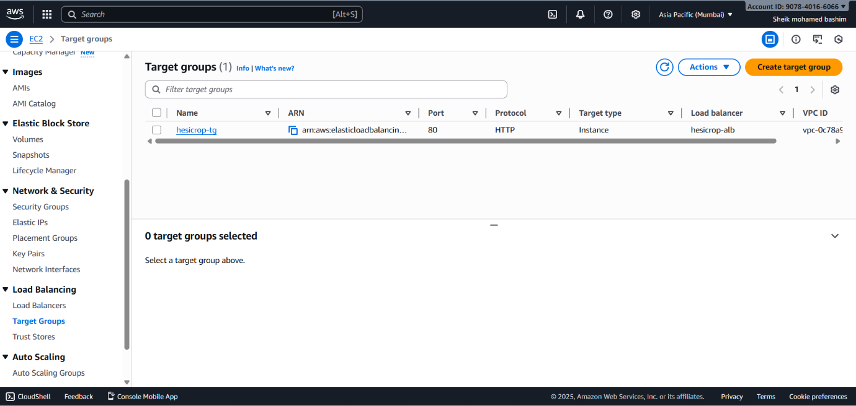

STEP 20: New Elastic Load Balancer is created automatically.
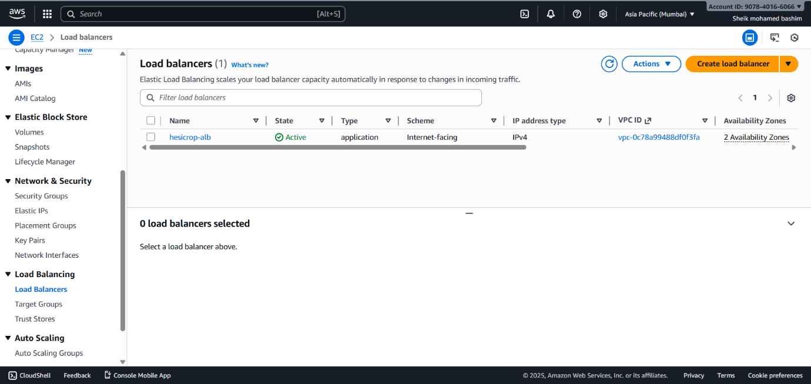

STEP 21: New Cloud Watch is created automatically.
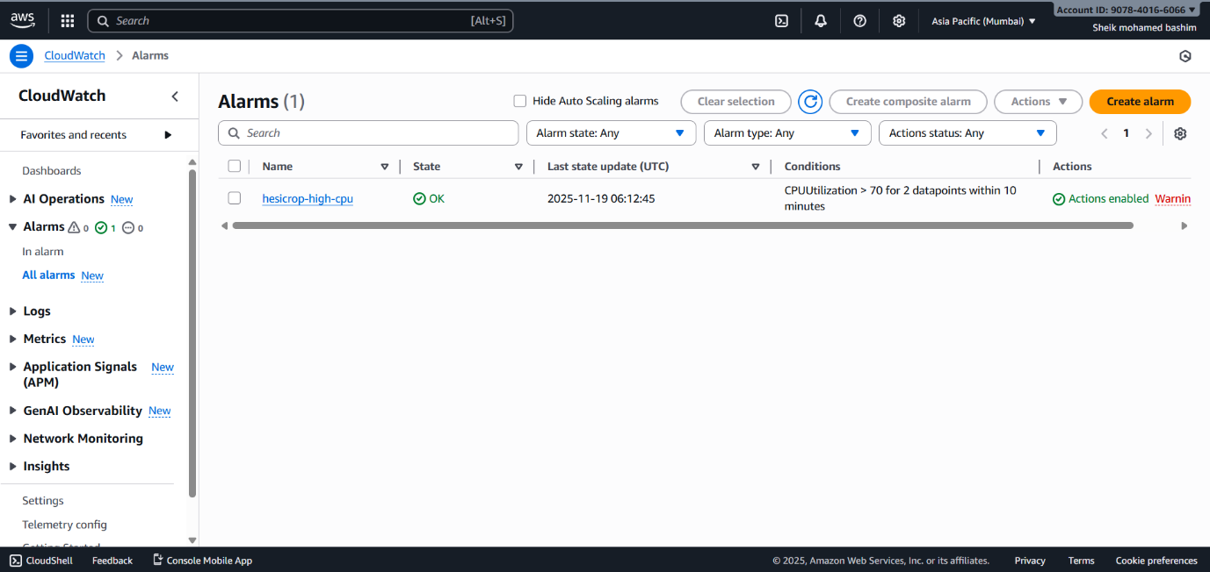

STEP 22: Confirm Subscription Email.
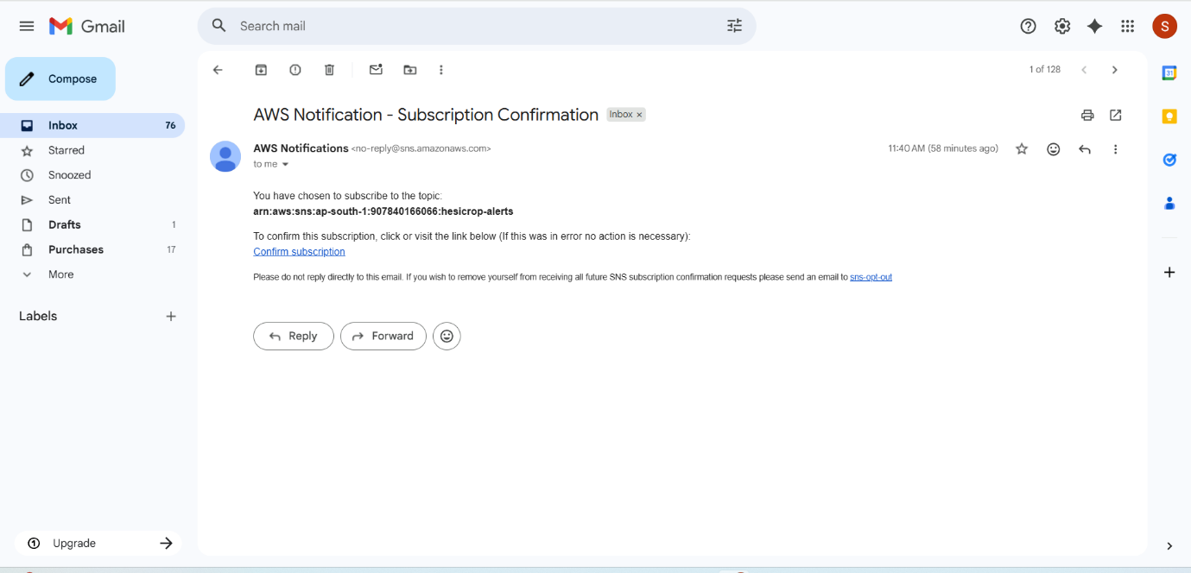

STEP 23: New SNS Topic & Subscription is created automatically.
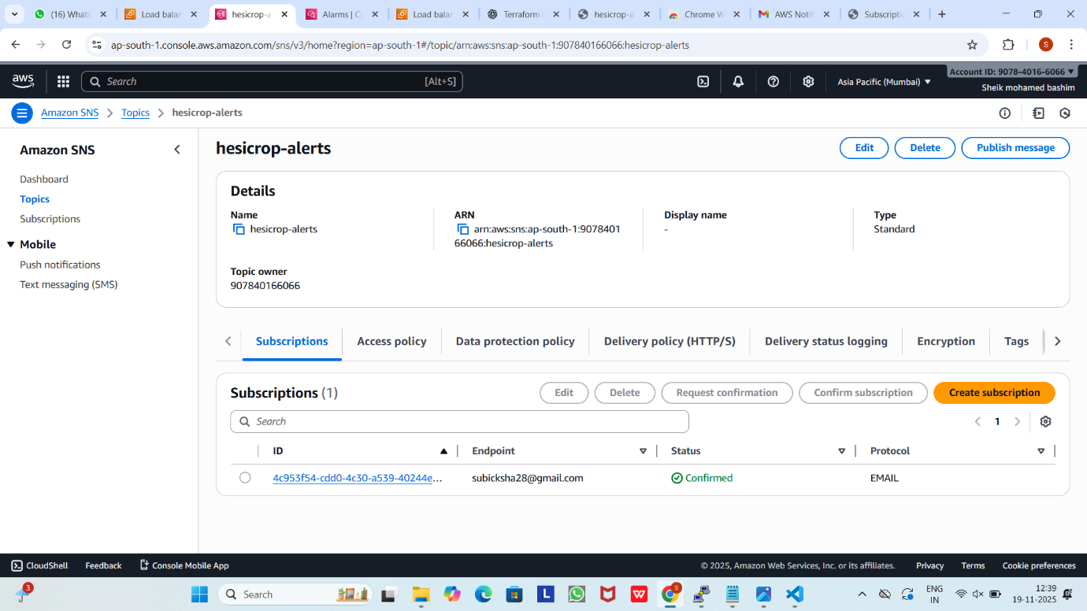

STEP 24: Access the webpage though the load balancer DNS.
